Binary Search

**Binary Search Algorithm: The basic steps to perform Binary Search are:**

Begin with the mid element of the whole array as a search key.

If the value of the search key is equal to the middle item then return an index of the search key.

Or if the value of the search key is less than the item in the middle of the interval, narrow the interval to the lower half.

Otherwise, narrow it to the upper half.

Repeatedly check from the second point until the value is found or the interval is empty.

**More Specific steps:**

1. Compare x with the middle element.
2. If x matches with the middle element, we return the mid index.
3. Else If x is greater than the mid element, then x can only lie in the right half subarray after the mid element. So we recur for the right half.
4. Else (x is smaller) recur for the left half.

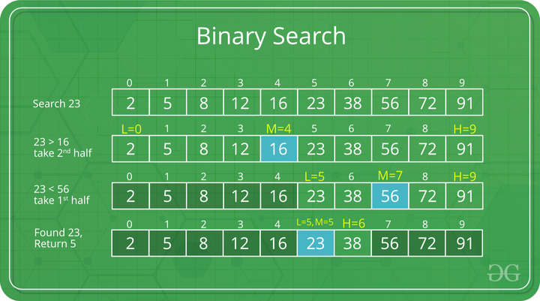

There are two ways to implement the binary search algorithm

1. Iterative way
2. Recursive Way

iterative Way

# Binary Search in python

def binarySearch(array, x, low, high):

    # Repeat until the pointers low and high meet each other

    while low <= high:

        mid = low + (high - low)//2

        if array[mid] == x:

            return mid

        elif array[mid] < x:

            low = mid + 1

        else:

            high = mid - 1

    return -1

array = [3, 4, 5, 6, 7, 8, 9]

x = 4

result = binarySearch(array, x, 0, len(array)-1)

if result != -1:

    print("Element is present at index " + str(result))

else:

    print("Not found")

# Recursive Way

def binarySearch(array, x, low, high):

    if high >= low:

        mid = low + (high - low)//2

        # If found at mid, then return it

        if array[mid] == x:

            return mid

        # Search the left half

        elif array[mid] > x:

            return binarySearch(array, x, low, mid-1)

        # Search the right half

        else:

            return binarySearch(array, x, mid + 1, high)

    else:

        return -1

array = [3, 4, 5, 6, 7, 8, 9]

x = 4

result = binarySearch(array, x, 0, len(array)-1)

if result != -1:

    print("Element is present at index " + str(result))

else:

    print("Not found")